**ASM Laboratory**



Name: **Soham Das**

Section: **A1**

Roll No: **002311001004**

**IT-UG2**

1. **Write an Assembly Language Program to add two sixteen-bit numbers. The numbers are stored in DS: 0030H and DS: 0040H. Store the result in DS: 0050H, DS: 0051H, and DS: 0052H**.

.model small

.stack 100h

.data

.code

main proc

mov ax, @data

mov ds, ax

mov cl, 00h

mov si, 0030h

mov ax, [si]

mov si, 0040h

mov bx, [si]

add bx, ax

adc cl, cl

mov si, 0050h

mov [si], bx

add si, 02h

mov [si], cl

int 03h

mov ah,4ch

int 21h

main endp

end main

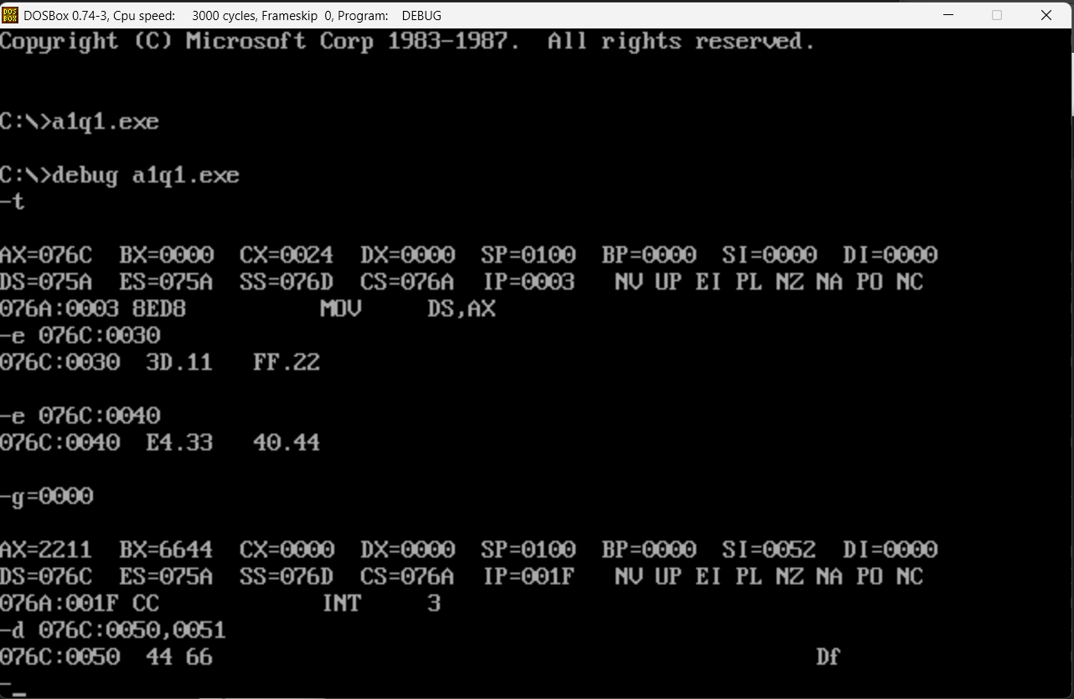

1. **Write an Assembly Language Program to subtract an 8-bit numbers stored in DS: 0030H from a number stored in DS: 0040H using 2’s complement method. Store the result in DS: 0050H, and DS: 0051H.**

.model small

.stack 100h

.data

.code

main proc

mov ax, @data

mov ds, ax

mov si, 0030h

mov al, [si]

not al

add al,01h

mov si, 0040h

add al,[si]

jc li

;neg al

;do not use <neg> as it will modify the carry

not al

inc al

li:

mov si, 0050h

mov [si],al

mov ah,00h

cmc

adc ah, ah

inc si

mov [si], ah

int 03h

mov ah,4ch

int 21h

main endp

end main

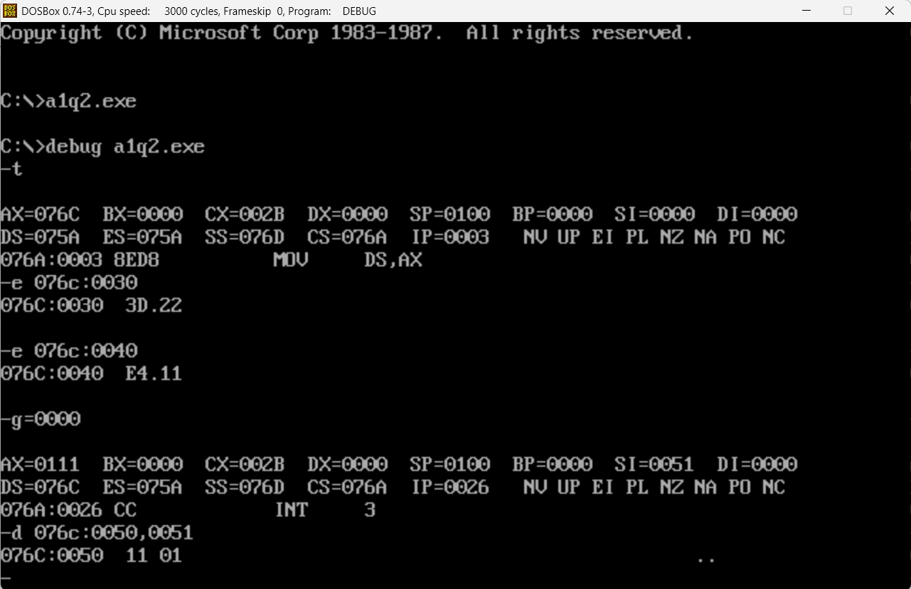

1. **Write a program to transfer a block of 8 data bytes from memory location DS: 0030H to DS: 0040H.**

.model small

.stack 100h

.data

.code

main proc

mov ax,@data

mov ds,ax

mov es,ax

mov si,0030h

mov di,0040h

cld

mov cx,0008h

rep movsb ;repeat command

mov ah,4ch

int 21h

main endp

end main

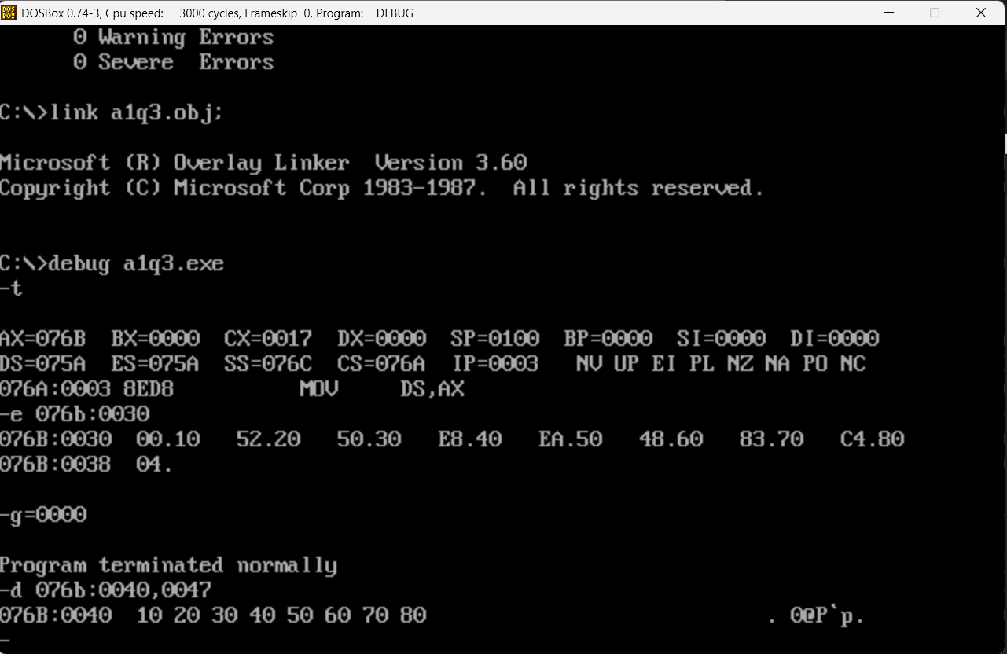

1. **Write an 8086 Assembly Language Program for the addition of 7 eight-bit numbers stored from DS: 0030H. Store the result in DS: 0050H and DS: 0051H.**

dosseg

.model small

.stack 100h

.data

.code

main proc

mov ax,@data

mov ds,ax

mov si,0030h

mov di,0050h

mov cx,0007h

mov ax,0000h

mov bx,0000h

l1: mov bl,[si]

add ax,bx

inc si

loop l1

mov [di],ax

int 03h

mov ah,4ch

int 21h

main endp

end main

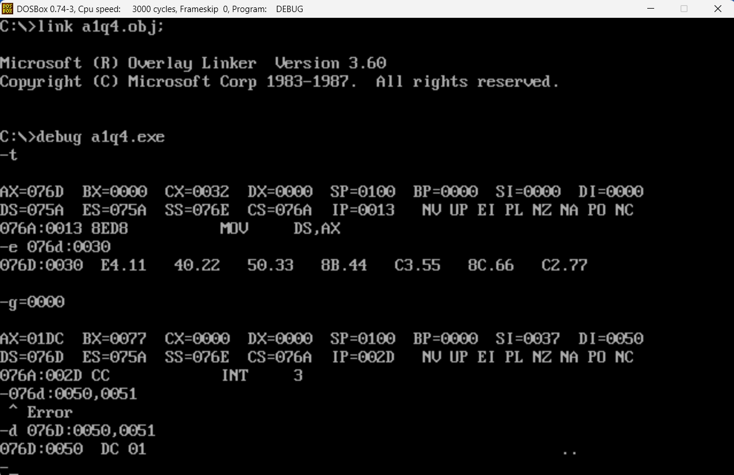

[Note: 11+22+…+77 = 01DC]

1. **Write an 8086 Assembly Language Program for the addition of 5 sixteen-bit numbers stored from DS: 0030H. Store the result in DS: 0050H, DS: 0051H, DS: 0052H.**

dosseg

.model small

.stack 100h

.data

.code

main proc

mov ax,@data

mov ds,ax

mov si,0030h

mov di,0050h

mov cx,0005h

mov ax,0000h

mov bx,0000h

mov dl,00h

l1: mov bx,[si]

add ax,bx

adc dl,00h

inc si

inc si

loop l1

mov [di],ax

inc di

inc di

mov [di],dl

int 03h

mov ah,4ch

int 21h

main endp

end main

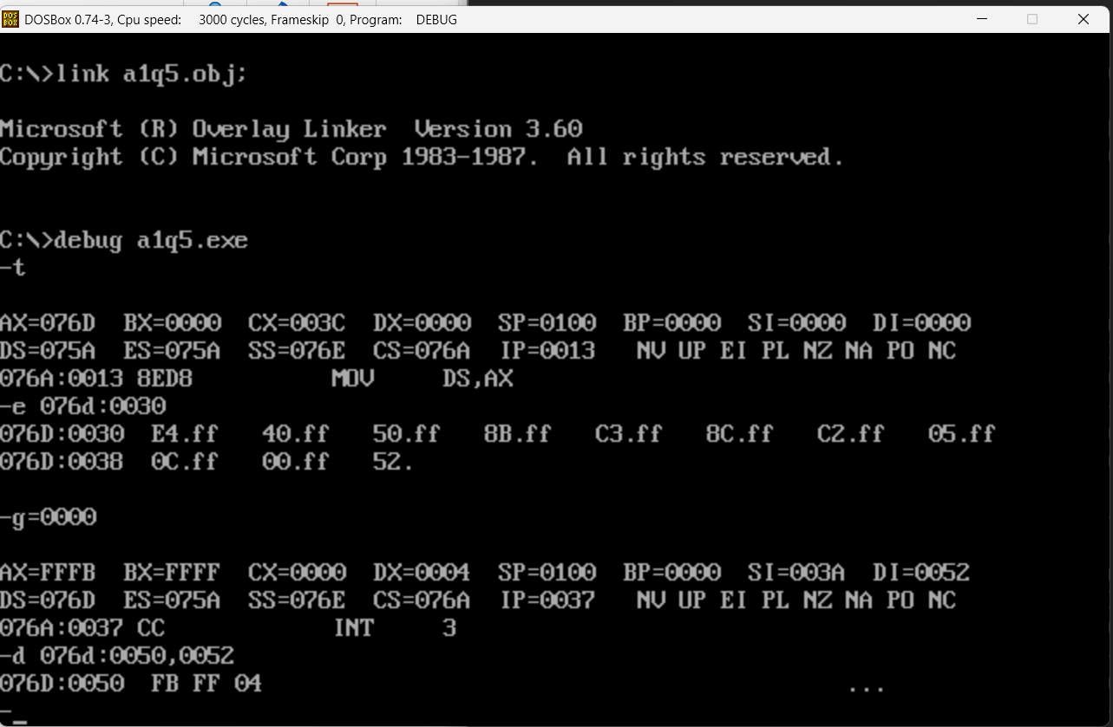

[Note: FFFF+FFFF+FFFF+FFFF+FFFF = 04FFFB]

1. **Write an Assembly Language Program for the addition of five BCD numbers stored from DS: 0030H. Store the result in DS: 0040H and DS: 0041H.**

dosseg

.model small

.stack 100h

.data

.code

main proc

mov ax, @data

mov ds, ax

mov si, 0030h

mov di, 0040h

mov cx, 0005h

mov ax, 0000h

mov dl, 00h

l1:

mov bl, [si]

add al, bl

daa

adc dl, 00h

inc si

loop l1

mov [di], al

inc di

mov [di], dl

int 03h

mov ah, 4Ch

int 21h

main endp

end main

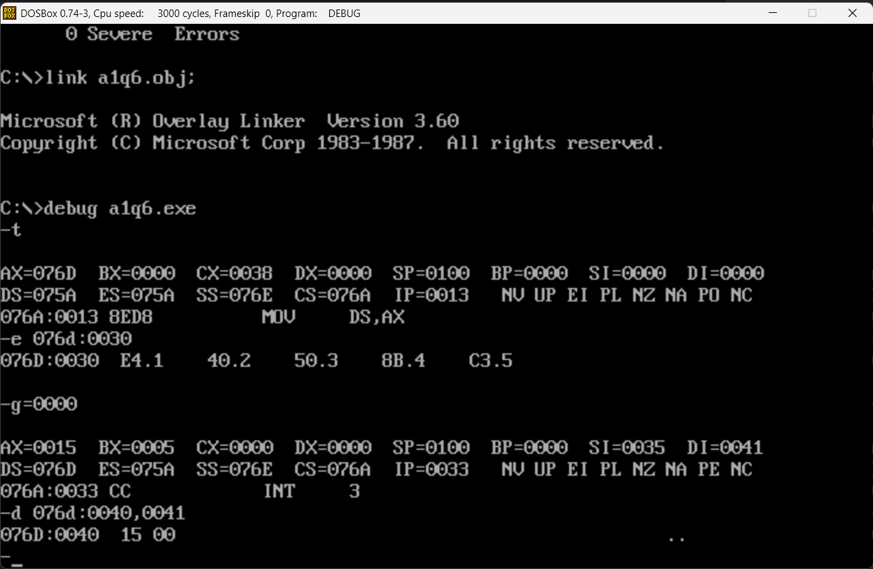

1. **Write an Assembly Language Program to subtract a BCD number stored in DS: 0040H from a BCD number stored in DS: 0050H. Store the result in DS: 0060H and DS: 0061H.**

dosseg

.model small

.stack 100h

.data

.code

main proc

mov ax,@data

mov ds,ax

mov si,0050h

mov al,[si]

mov si,0040h

sub al,[si]

das

mov si,0060h

mov [si],al

mov ah,00h

adc ah,ah

inc si

mov [si],ah

int 03h

mov ah,4ch

int 21h

main endp

end main

1. **Write an Assembly Language Program to multiply two eight bit number stored in DS: 0040H and DS: 0050H. Store the result from DS: 0060H**.

dosseg

.model small

.stack 100h

.data

.code

main proc

mov ax,@data

mov ds,ax

mov si,0040h

mov al,[si]

mov si,0050h

mov bl,[si]

mul bl

mov si,0060h

mov [si],ax

int 03h

mov ah,4ch

int 21h

main endp

end main

1. **Write an Assembly Language Program to multiply two sixteen bit number stored in DS:0040H and DS:0050H. Store the result from DS: 0060H.**

dosseg

.model small

.stack 100h

.data

.code

main proc

mov ax,@data

mov ds,ax

mov si,0040h

mov ax,[si]

mov si,0050h

mov bx,[si]

mul bx

mov si,0060h

mov [si],ax

mov si,0062h

mov [si],dx

int 03h

mov ah,4ch

int 21h

main endp

end main

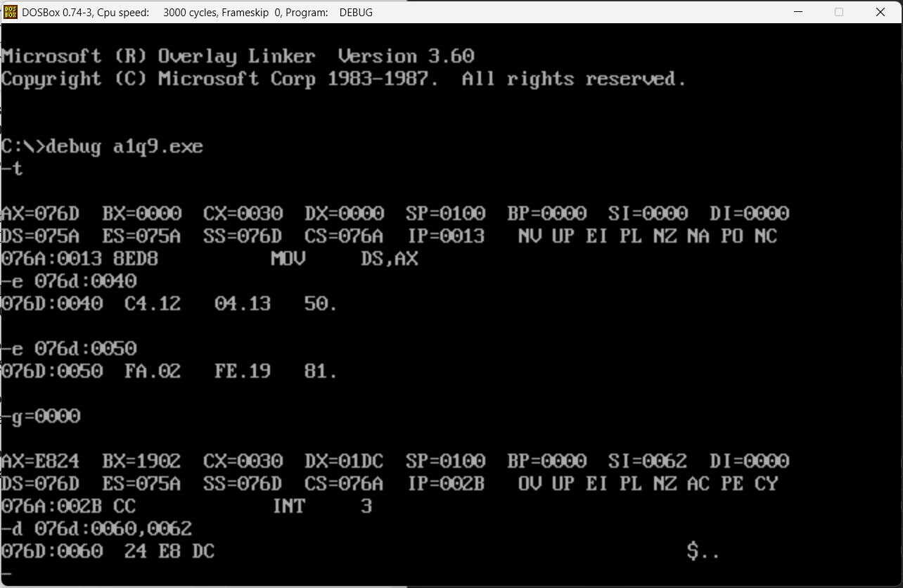

1. **Write an Assembly Language Program to divide 88H by 33H. Store the quotient in DS: 0060H and remainder in DS: 0061H**.

.model small

.stack 100h

.data

.code

main proc

mov ax, @data

mov ds, ax

mov si,0040h

mov ax,[si]

mov si,0050h

mov bl,[si]

div bl

mov si,0060h

mov [si],ax

int 03h

mov ah,4ch

int 21h

main endp

end main

1. **Write an Assembly Language Program to divide 2222H by 55H. Store the quotient from DS: 0060H and remainder in DS: 0062H.**

dosseg

.model small

.stack 100h

.data

.code

main proc

mov ax,@data

mov ds,ax

mov si,0040h

mov ax,[si]

mov si,0050h

mov bx,[si]

div bx

mov si,0060h

mov [si],ax

mov si,0062h

mov [si],dx

int 03h

mov ah,4ch

int 21h

main endp

end main

